Contents

-Creating a Promise 2

-Example 2

# -Creating a Promise

A Promise object is created using the new keyword and its constructor. This constructor takes as its argument a function, called the "executor function". This function should take two functions as parameters. The first of these functions (resolve) is called when the asynchronous task completes successfully and returns the results of the task as a value. The second (reject) is called when the task fails, and returns the reason for failure, which is typically an error object.

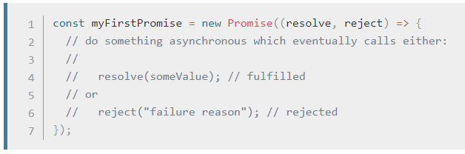

注释：

Promise 使用new关键字创建；

Promise创建时传入的参数是一个function，该function为此promise创建时的构造函数constructor；

Constructor接受两个function为输入参数：resolve和reject；

如异步任务成功完成后，需调用resolve函数，并返回任务结果；

如异步任务失败，则调用reject函数，并返回失败原因；

# -Example

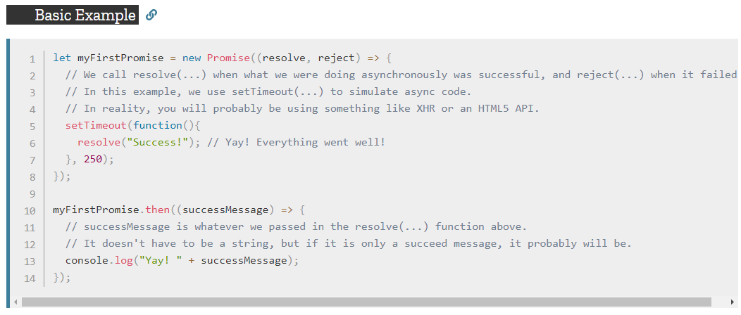

250ms后打印“Yay! Success!”